CHECK CONSTRAINT: Creating a table with check constraints

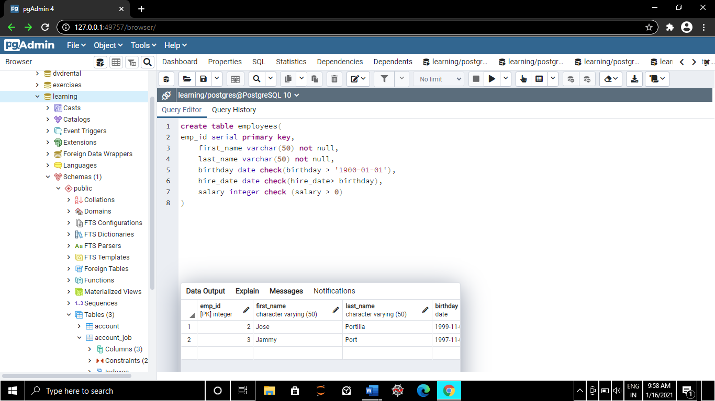

Inserting values

